SUPERSET ID-7638914
DATA STRUCTURES AND ALGORITHMS
Exercise 1: Inventory Management System
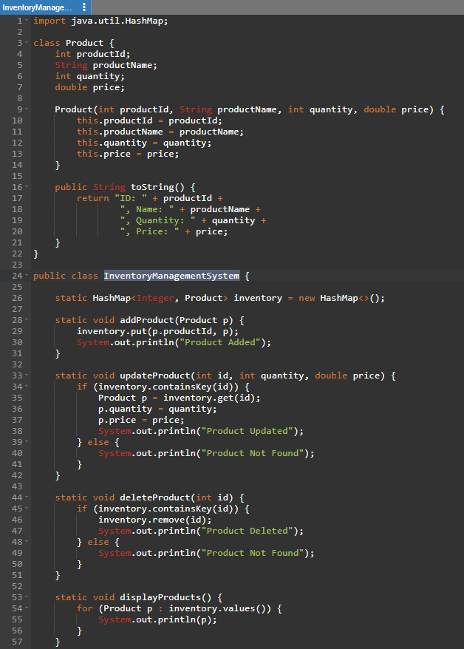
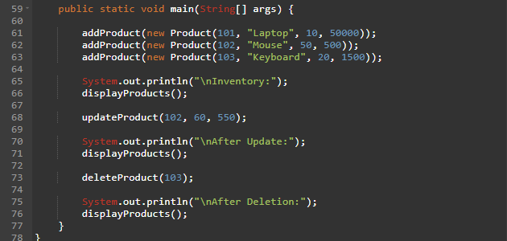
OUTPUT:
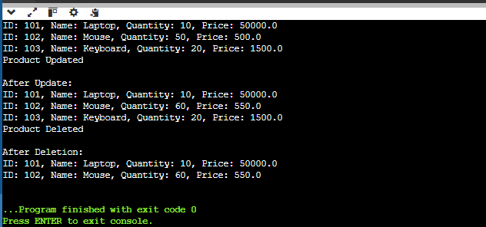
Why DSA?
- Fast storage and retrieval of products.
- Efficient updates and deletions.
- Handles large inventories efficiently.
Suitable Data Structures
- ArrayList
- HashMap (Best choice for productId lookup)

Exercise 2: E-commerce Platform Search Function
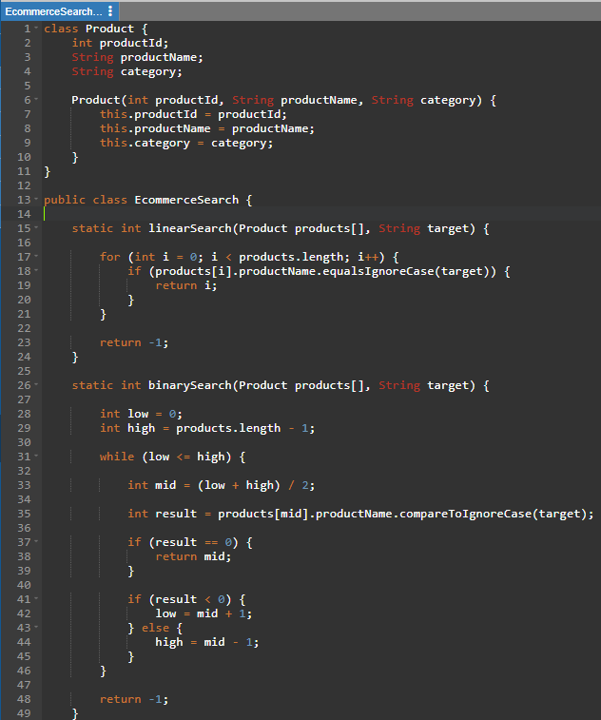

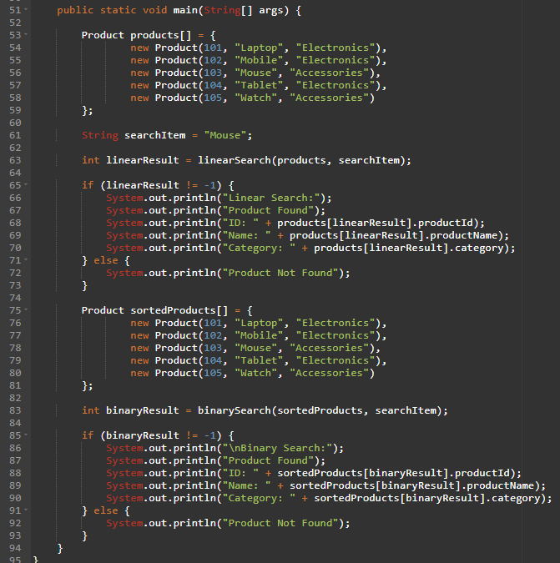
OUTPUT:

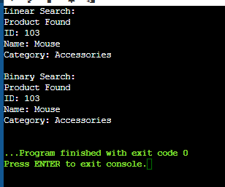

Case | Linear | Binary
Best | O(1) | O(1)
Average | O(n) | O(log n)
Worst | O(n) | O(log n)
Binary Search is preferred because O(log n) is much faster than O(n).

Exercise 3: Sorting Customer Orders
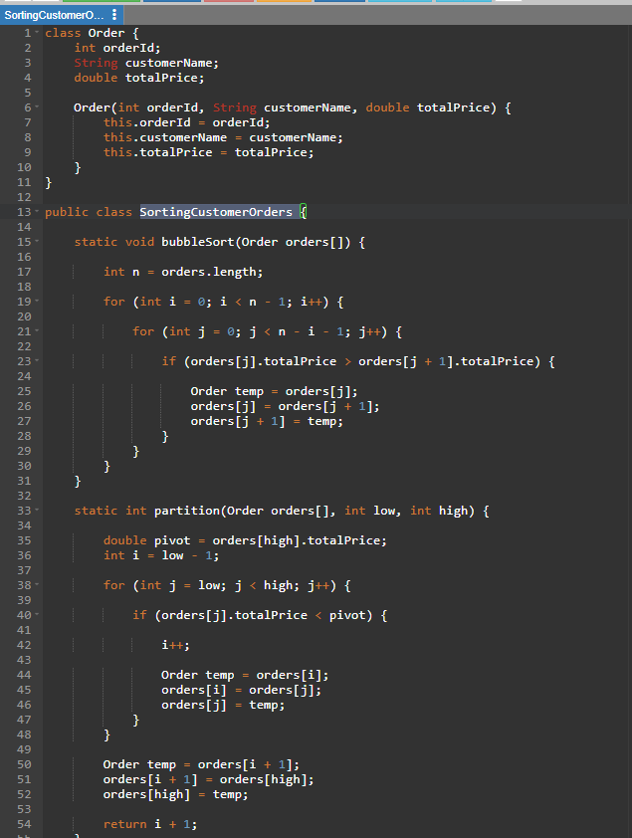
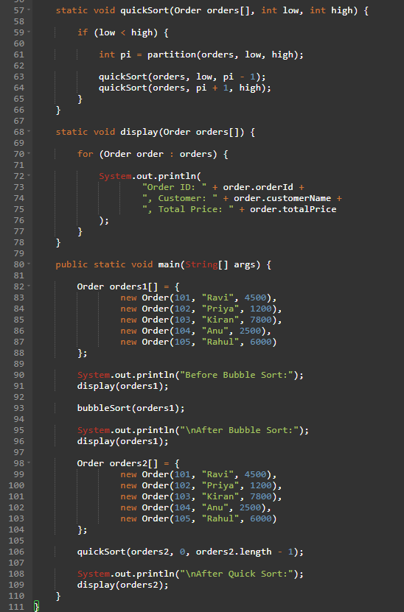

OUTPUT:
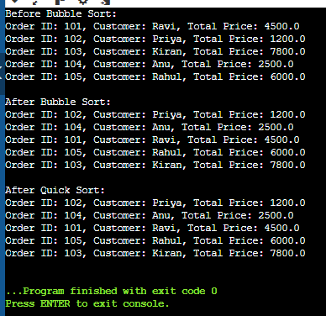
Algorithm | Complexity
Bubble Sort | O(n²)
Insertion Sort | O(n²)
Quick Sort | O(n log n)
Merge Sort | O(n log n)

Why Quick Sort?
- Faster for large datasets.
- Average O(n log n).
- Bubble Sort becomes slow as data grows.

Exercise 4: Employee Management System
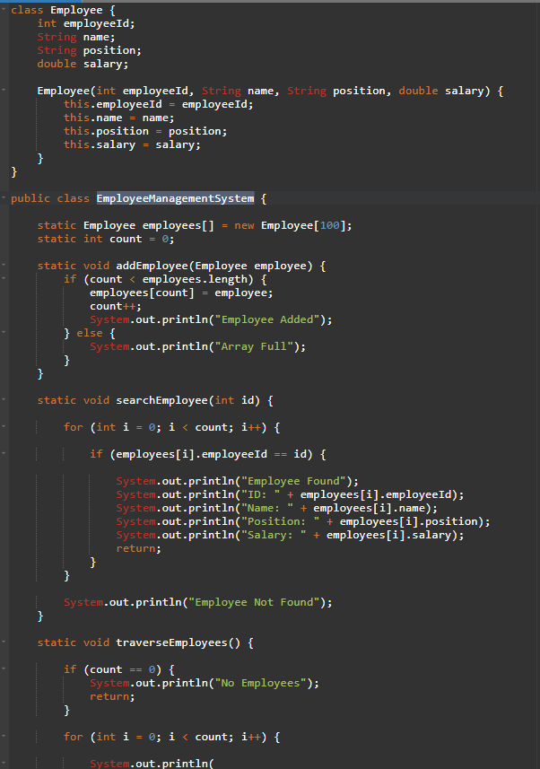
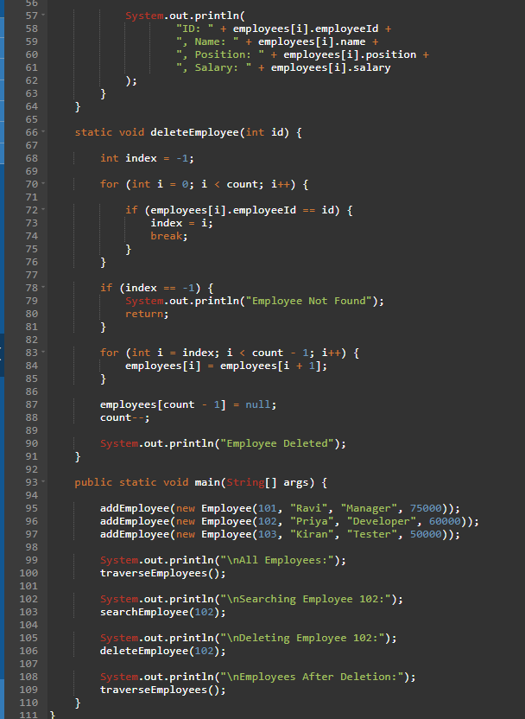

OUTPUT:

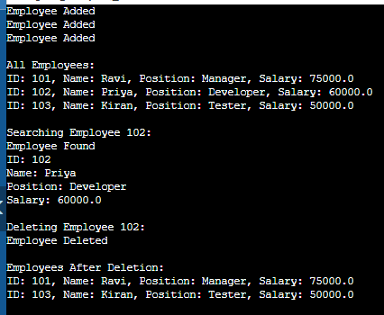
Complexity
Operation | Complexity
Add | O(1)
Search | O(n)
Traverse | O(n)
Delete | O(n)
Limitation
Fixed size. Cannot grow dynamically.

Exercise 5: Task Management System
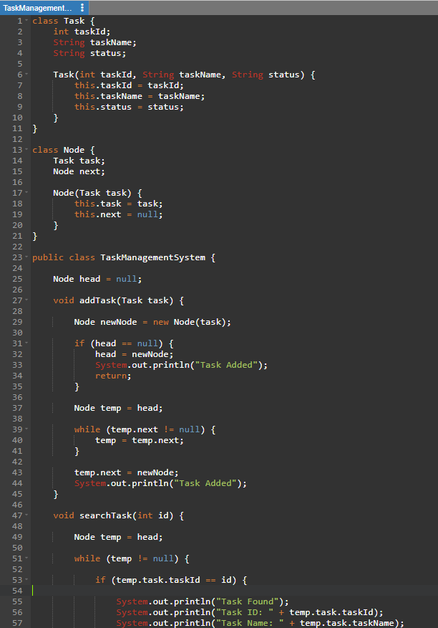
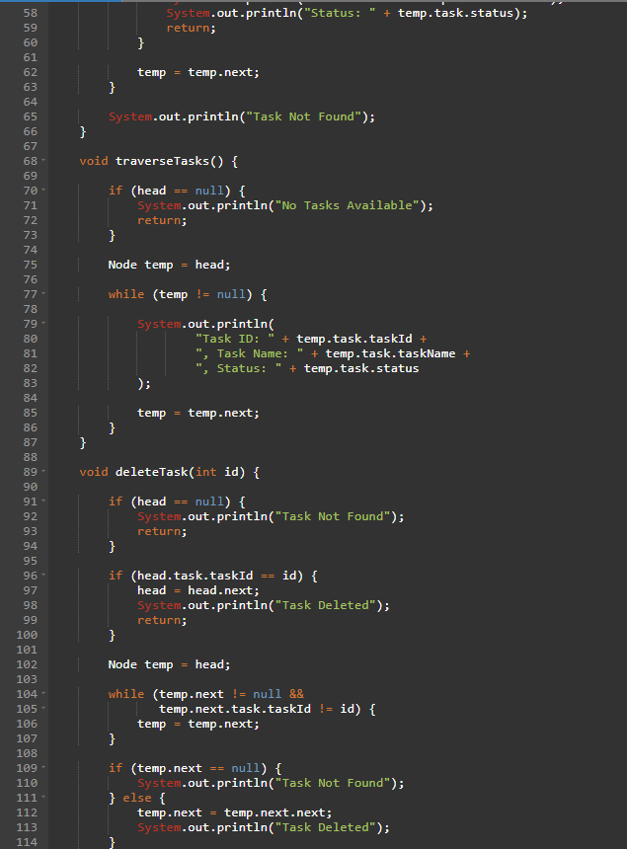
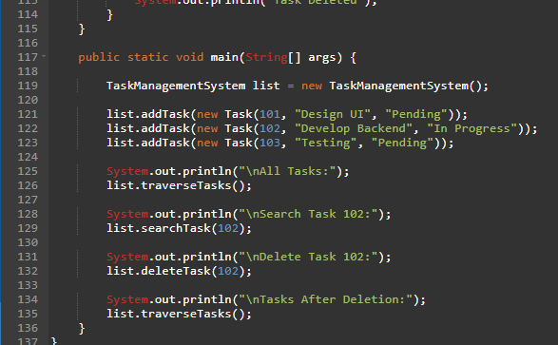
OUTPUT:

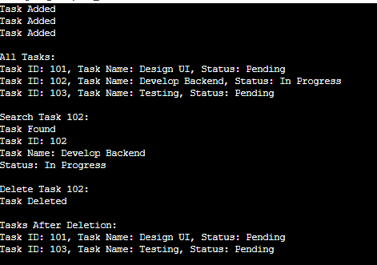
Types of Linked Lists
- Singly Linked List
- Doubly Linked List

Complexity
Add | -O(n)
Search | -O(n)
Traverse | -O(n)
Delete | -O(n)

Advantage

Dynamic size and efficient insertions.

Exercise 6: Library Management System
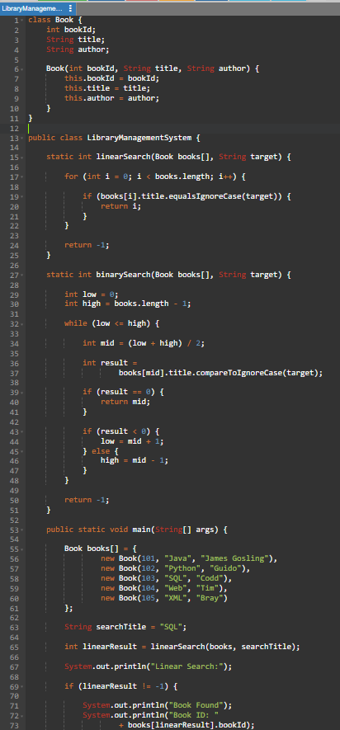
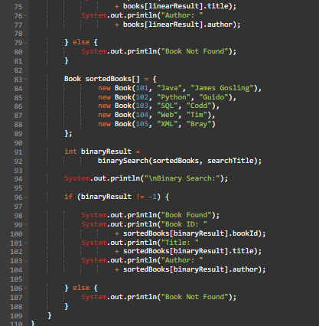
OUTPUT:

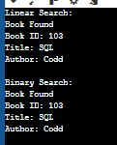
Complexity
LINEAR-O(N)
BINARY SEARCH-0(LOG N)
Use Binary Search when data is sorted.

Exercise 7: Financial Forecasting
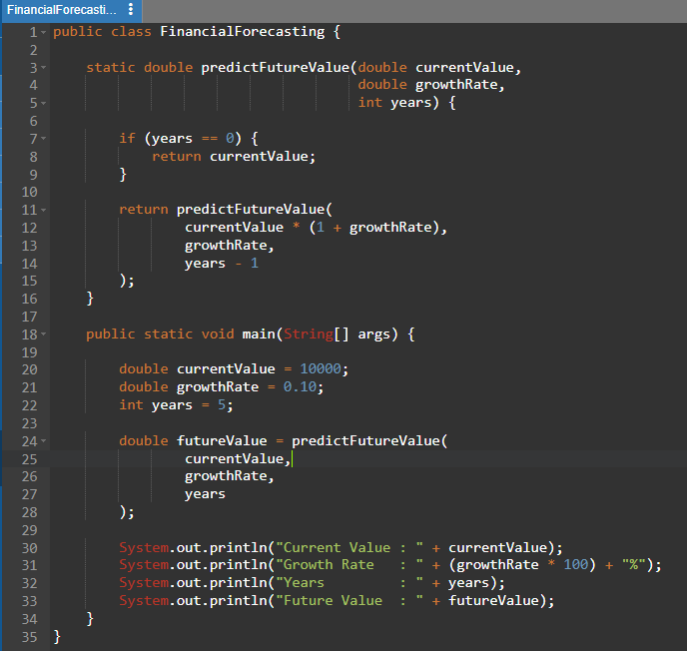
OUTPUT:

RECURSION-O(N)
OPTIMIZED FORMULA-O(1)
Optimization:
double future = principal * Math.pow(1 + growth, years);

